III) The pedigree drawn below represents a very rare disease. Study it carefully and answer all questions below.

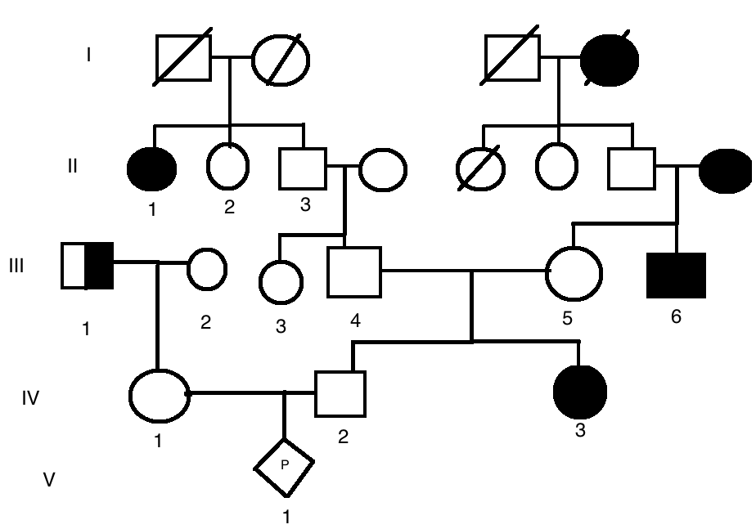

1- What are the possible genotypes of individuals III-1, II-2 and III-5? (0.5 pt/each)

2- What is the probability that V-1 fetus is a carrier? Affected? Show your work (calculations) (3 pts)

1-In Drosophila, forked (fk) bristles are recessive to normal (fk+) and glassy eyes (gls) are recessive to normal (gls+). If a homozygous wild-type male is mated to a forked-bristled, glassy-eyed female, predict the genotypes and phenotypes of the F2.

II) Fruit flies with one allele for curly wings (Cy) and one allele for normal wings (Cy⁺) have curly wings. When two curly-winged flies were crossed, 203 curly-winged and 98 normal winged flies were obtained. In fact, all crosses between curly-winged flies produced nearly the same curly:normal ratio among the progeny.
a) What is the approximate phenotypic ratio in these offspring? (1pt)

b) Suggest an explanation for these data? (2pts)

